**DBMS LAB WEEK3**

**NAME: Divyanshu Sharma**

**SRN: PES1UG20CS806**

**Section: D**

**Draw ER Diagram for the following:**

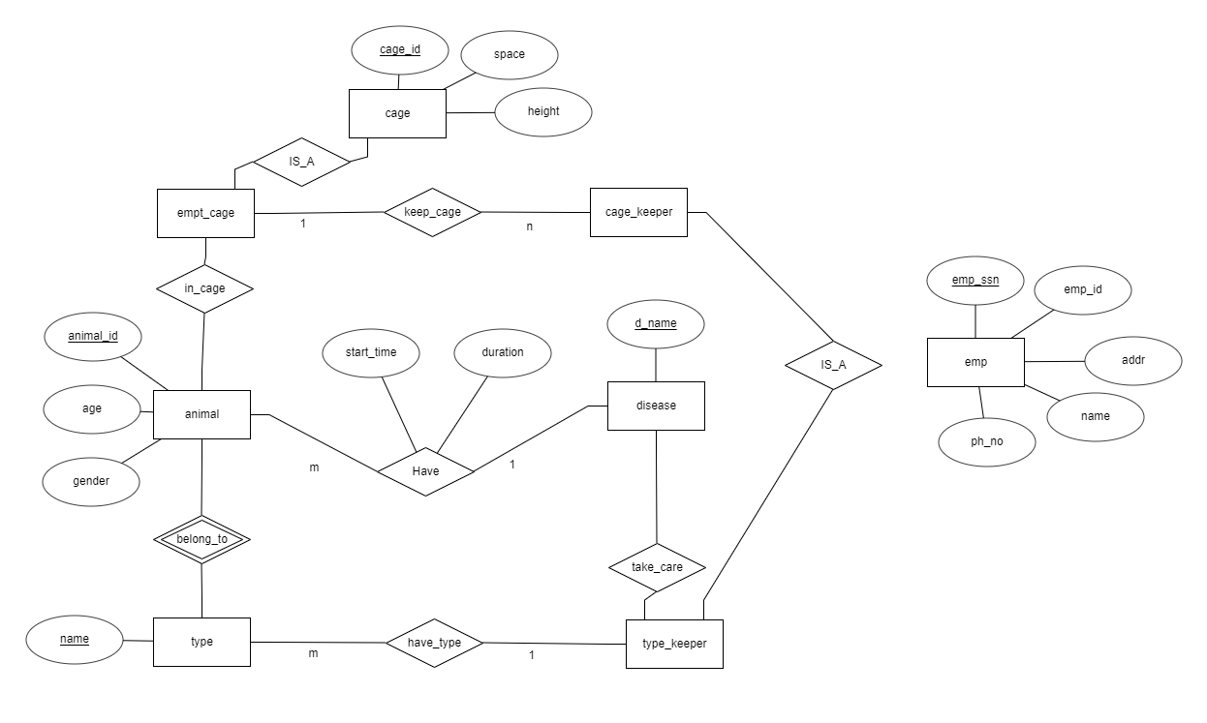The Bannerghatta Biological Zoo has many types of animals. Every type has a unique name. Every animal of the same type has a unique animal ID. Animals in two types may have the same animal ID. Animals also have age and gender. Animals may have diseases. The beginning time and the duration of a disease need to be recorded. A disease has a unique name. A type keeper takes care of only one type of animals. Every type may have many type keepers. A type keeper may or may not be familiar with diseases. But every disease must be handled by at least one type keeper. Type keepers have name, employee ID, ssn, address and phone number. All animals are in cages. Some cage may be empty. Every cage has a cage ID, space and height. A cage keeper may take care of many cages. Every non-empty cage must have at least one cage keeper. Empty cages don’t need any cage keepers. Cage keepers have name, employee ID, ssn, address and phone number.

**Convert the ER diagram of zoo into Relational table**

|  |
| --- |
| Take_care |
| D_name |
| Emp_ssn |
| D_type |

|  |  |
| --- | --- |
| Empt_cage | |
| Pk | **Cage_id** |
|  | Space |
|  | height |

|  |  |
| --- | --- |
| animal | |
| pk | **Animal_id** |
|  | Age |
|  | Gender |
| fk | Typename |
|  | Cage_id |

|  |  |
| --- | --- |
| type | |
| pk | **Name** |
|  | Animal id |
|  | Emp_ssn |

|  |  |
| --- | --- |
| disease | |
| pk | **D_name** |
|  | Animal_id |

|  |  |
| --- | --- |
| Have | |
|  | Animal_id |
|  | D_name |
|  | duration |
|  | Start_time |

|  |  |
| --- | --- |
| Employee | |
| Pk | **Emp_ssn** |
|  | Name |
|  | Addr |
|  | Ph_no |
|  | Emp_type |
|  | Emp_id |

**Write create statements for following considering constraints appropriately**

Doctor(**d_id**,d_name,d_phone)

Patient(**p_id**,p_name,diagnosis,age)

Medicine(**med_id**,med_name)

Prescription(**p_id,d_id**,med_id)

Bed(**B_id**,ward_no)

Bed_Patient(**p_id,b_id**,in_date,out_date)

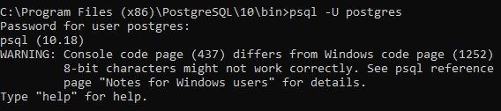

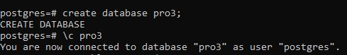**Creating Database and making connection with it:**

**Creating table Doctor and inserting value in it**

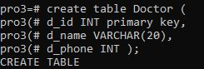

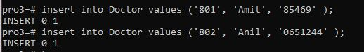

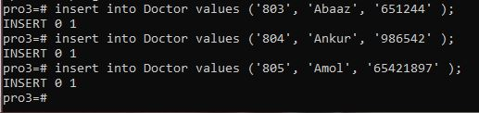

**Creating table Patient and inserting value in it:**

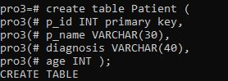

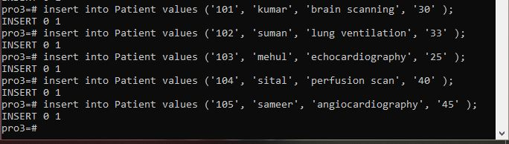

**Creating table Medicine and inserting value in it:**

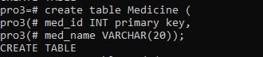

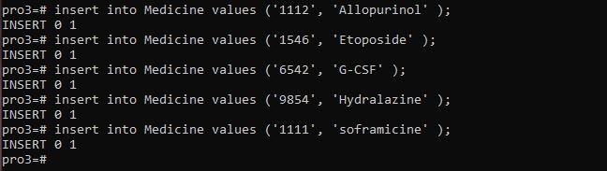

**Creating table Prescription and inserting value in it:**

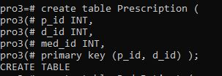

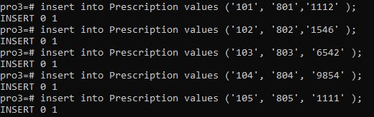

**Creating table Bed and inserting value in it:**

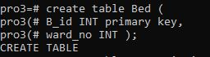

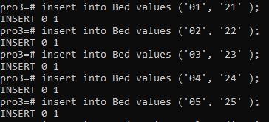

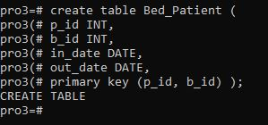**Creating table Bed_Patient and inserting value in it:**

